|  |  |
| --- | --- |
|  | ***Study*** |

Read chapter 13 of the following book:

Learning Python:

<http://www.dsf.unica.it/~fiore/LearningPython.pdf>

Then answer the quiz in page 414

1. What are the main functional differences between a ***while*** and a ***for***?

Python’s ***while*** statement repeatedly executes a block of (normally indented) statements as long as a test at the top keeps evaluating to a true value.

***for*** statement, is designed for stepping through the items in a sequence or other iterable object and running a block of code for each.

2. What’s the difference between ***break*** and ***continue***?

***break***Jumps out of the closest enclosing loop (past the entire loop statement)  
***continue***  
Jumps to the top of the closest enclosing loop (to the loop’s header line)

3. When is a loop’s ***else*** clause executed?

The loop ***else*** clause is also run if the body of the loop is never executed, as you don’t run a break in that event either; in a while loop, this happens if the test in the header is false to begin with

4. How can you code a counter-based loop in Python?

Using ***while*** statement that keeps track of the index manually

Using the ***range*** built-in function in ***for*** loop

5. What can a ***range*** be used for in a for loop?

04 types:

built-in ***range*** function: series of successively higher integers

|  |  |
| --- | --- |
|  | ***Serious exercises*** |

**Exercise 1**: Write a program to check whether a number is a prime number

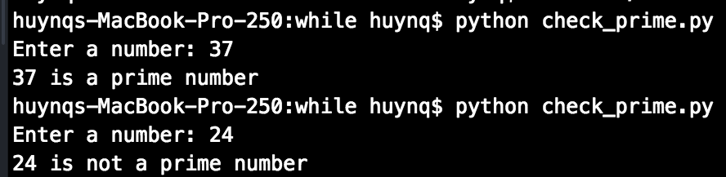

**Exercise 2**: Modify the username password in previous session to allow users login at maximum 3 times

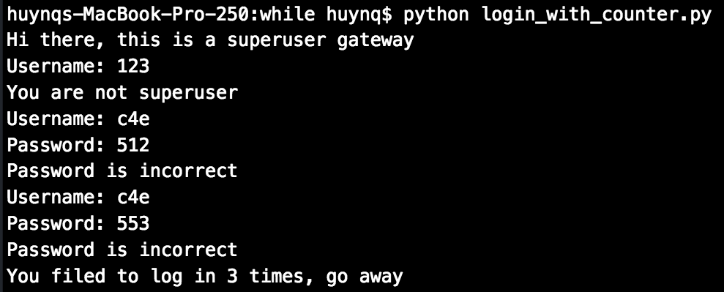

**Exercise 3 (Optional)**: Modify guess_my_number.py to the opposite scenario, you think of a number and then the program takes a guess, then you tell it where its guess is correct, smaller or larger than the number you’re thinking

